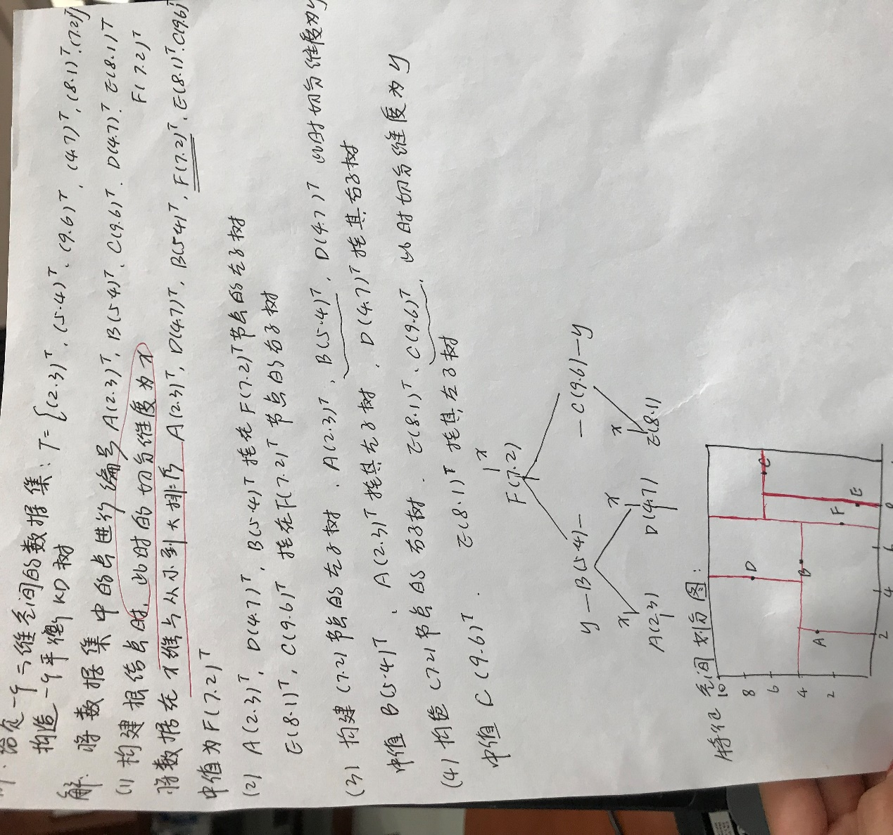附上一张自己手写的笔记：根据给出的数据集构建KdTree

其构建过程参考如下链接：

<https://leileiluoluo.com/posts/kdtree-algorithm-and-implementation.html>

其查找搜索过程参考如下链接：  
https://blog.csdn.net/losteng/article/details/50893739